Email Filing Application
Right click on emails in Inbox, suggested locations are normally the last 10 used.
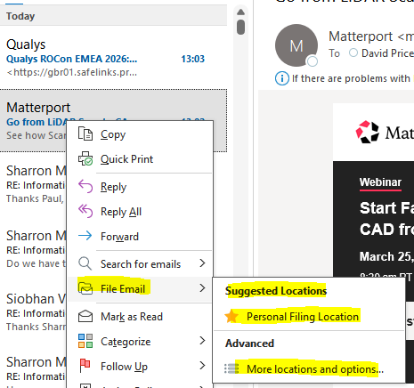
Outlook Toolbar
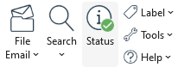

On the toolbar of Outlook - Elements required are File Email, Search and Options
File Email,
Manage can be removed as you can just right click on the location and rename and delete if needed. The green tick says the network location is connected. The select multiple just allows multiple locations to be selected at once to file a single email. The side bar options are simple
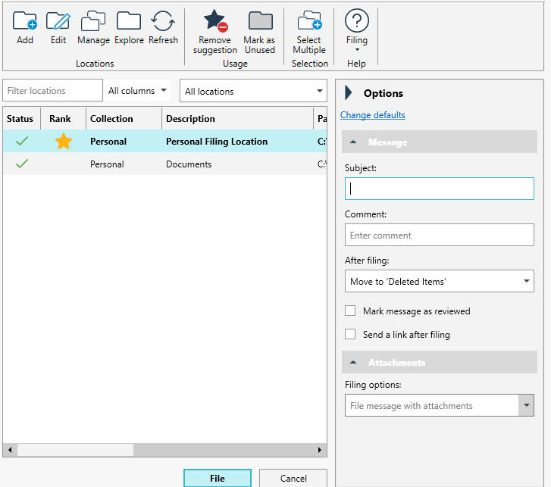

Clicking on the Add button results in the below :
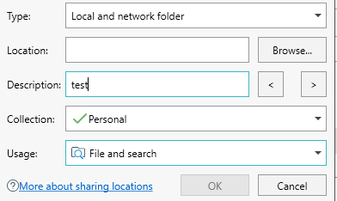
Manage allows for collections to be created which can be selected like Personal emails and certain project emails but I think that could be integrated into the Add, does not need a separate Manage button.

Search can be a simple search window like the below:
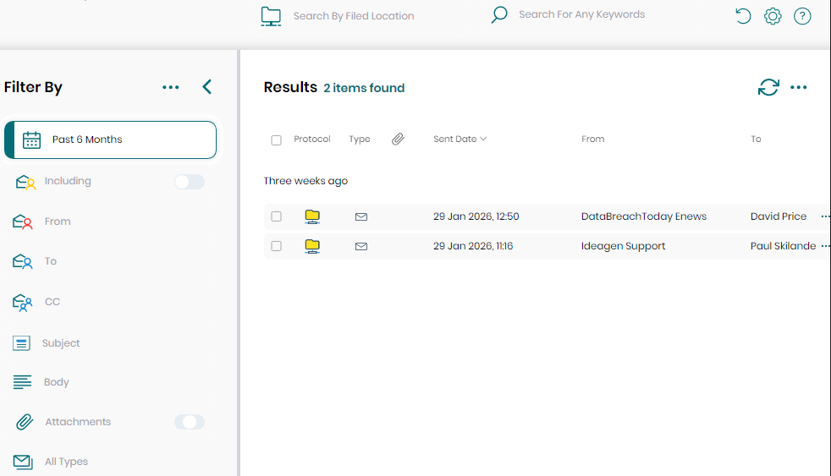

User preferences
Options highlighted are what we need, maybe 365 integration later

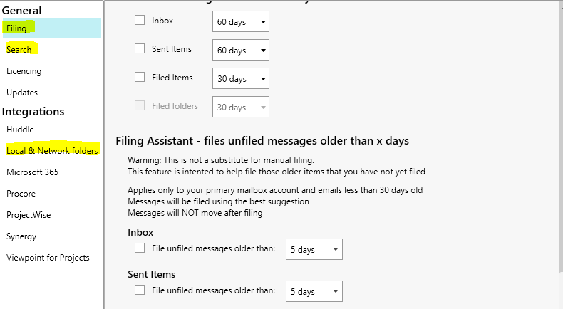
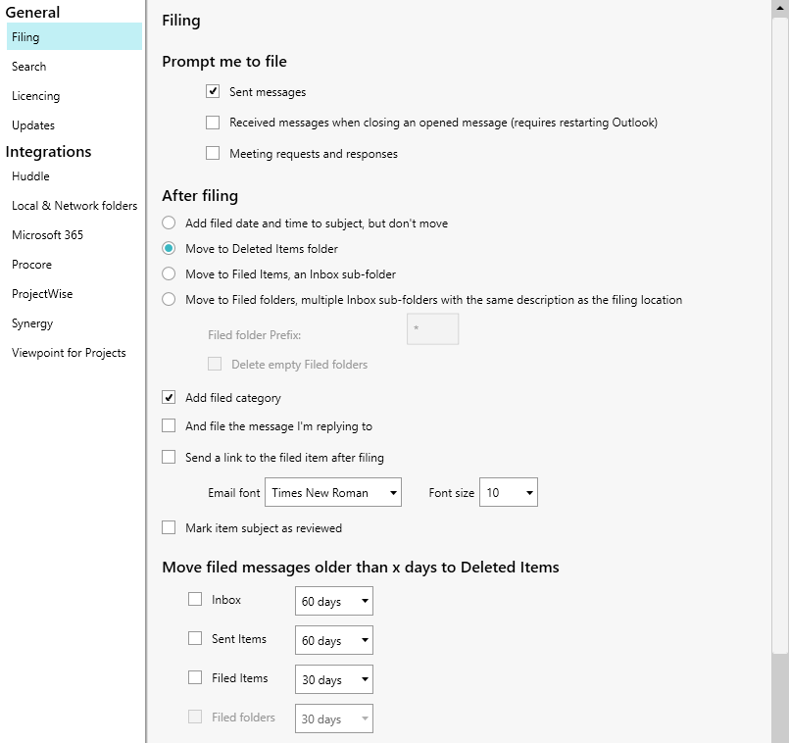
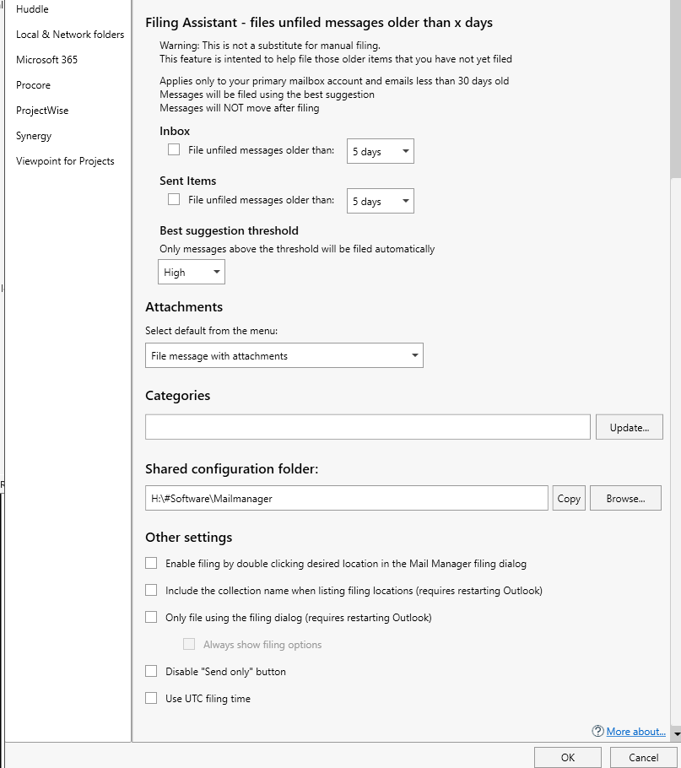

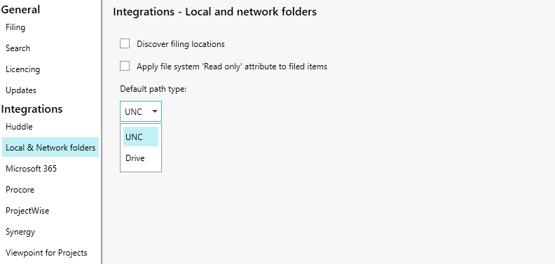

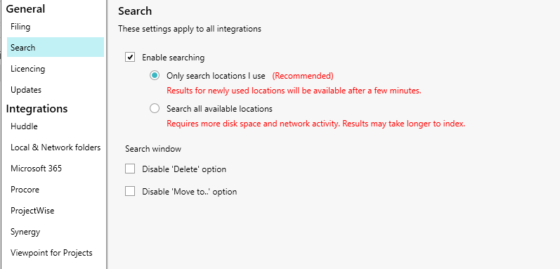

We don’t need this for now, but in the future 365 integration :

